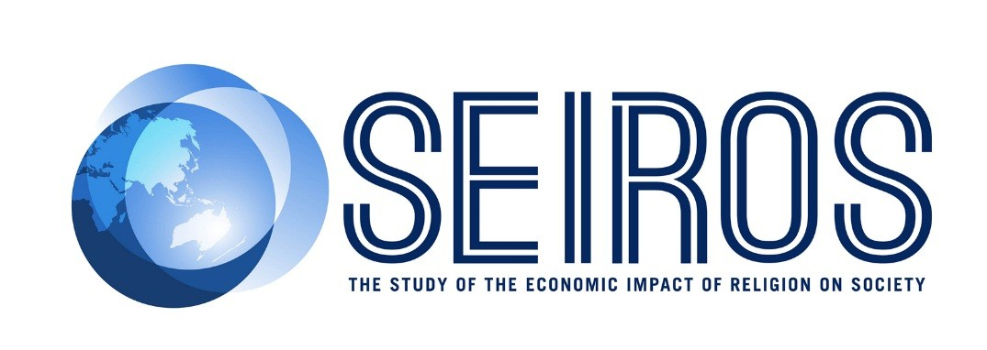

New Study finds religious people are more generous with time and money

Minister Dutton today launched new pathbreaking research on the economic impact of religion in Australia.

The research, conducted by Deloitte Access Economics, found that people who begin attending religious services as adults have a higher likelihood of volunteering and donating than people who have never attended religious services.

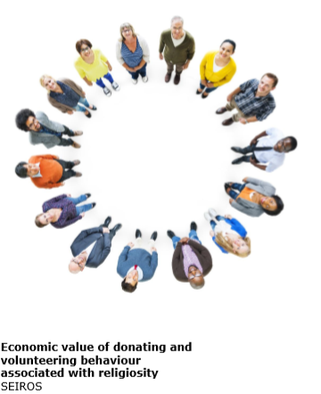
This research is the first in a series of reports from a new national organisation called SEIROS – short for ‘The Study of the Economic Impact of Religion on Society’. It includes leaders and representatives from different religious traditions, academics and policy makers.

The research uses new data from a national survey of over 7,000 Australians and finds:
- Individuals who started attending religious services as adults are 1 .7 times more likely to be a volunteer and 1.5 times more likely to make donations (compared to people who have never attended religious services).
- The additional volunteers and donors associated with religiosity are estimated to give an additional 30.5 million hours of volunteering per year with an economic value of at approximately $339 million to the Australian economy, and additional donations of around $142 million.
- The total estimated annual value to the Australian economy of volunteering and giving done by people who start attending religious services as adults is approximately $481 million.
The report was launched by Minister Dutton at 10am Thursday 31 May at Parliament House Canberra.
Media contact: Keith Thompson +64 22343 5261 (keith.thompson@nd.edu.au)

